## 1.1: Data Query Language

1. List the Name and Designation code of the staff who have joined before Jan 2003 and whose salary range is between 12000 and 25000. Display the columns with user defined Column headers. Hint: Use As clause along with other operators

Ans-MariaDB [rdbms]> select staff_name as Name,design_code as Designation_code from staff_masters where hiredate<'2003-01-01' and staff_sal between 12001 and 24999;

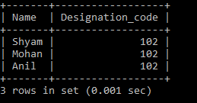

1. List the staff code, name, and department number of the staff who have experience of 18 or more years and sort them based on their experience.

Ans- MariaDB [rdbms]> select staff_code,staff_name,dept_code from staff_masters where timestampdiff(YEAR,hiredate,now())>=18 order by hiredate;

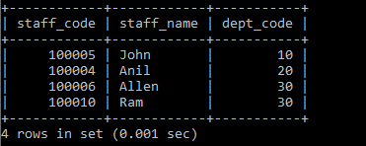

1. Display the staff details who do not have manager.

Ans- MariaDB [rdbms]> select * from staff_masters where mgr_code is null;



1. Display the Book details that were published during the period of 2001 to 2004. Also display book details with Book name having the character ‘&’ anywhere.

Ans- MariaDB [rdbms]> select * from book_masters where Book_pub_year between 2001 and 2004 or Book_name like "%&%";

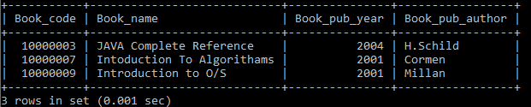

1. List the names of the staff having ‘_’ character in their name.

Ans- MariaDB [rdbms]> select staff_name from staff_masters where staff_name like "%\_%";



## 2.1: Single Row Functions:

1. Create a query which will display Staff Name, Salary of each staff. Format the salary to be 15 characters long and left padded with ‘$’.

Ans- MariaDB [rdbms]> select staff_name,lpad(staff_sal,15,"$") from staff_masters;

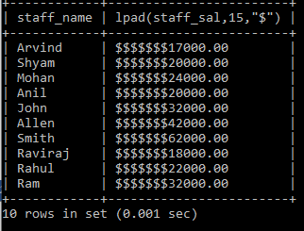

1. 2. Display name and date of birth of students where date of birth must be displayed in the format similar to “January, 12 1981” for those who were born on Saturday or Sunday.

Ans- MariaDB [rdbms]> select student_name,date_format(student_dob,"%M,%D %Y") as DateOfBirth from student_masters where dayofweek(student_dob) in(1,7);

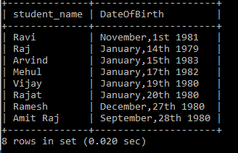

1. Display each Staff name and number of months they worked for the organization. Label the column as ‘Months Worked’. Order your result by number of months employed. Also Round the number of months to closest whole number.

Ans- MariaDB [rdbms]> select staff_name,timestampdiff(month,hiredate,now()) as Months_Worked from staff_masters order by Months_Worked desc;

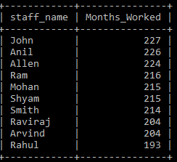

1. List the details of the staff who have joined in first half of December month (irrespective of the year).

Ans- MariaDB [rdbms]> select * from staff_masters where day(hiredate)<=15 and month(hiredate)=12;

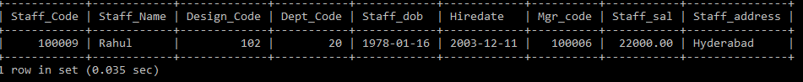

1. Write a query that displays Staff Name, Salary, and Grade of all staff. Grade depends on the following table.

|  |  |
| --- | --- |
| Salary | Grade |
| Salary >=50000 | A |
| Salary >= 25000 < 50000 | B |
| Salary>=10000 < 25000 | C |
| OTHERS | D |

Ans- MariaDB [rdbms]> select staff_name,staff_sal, case when staff_sal>=50000 then "A" when staff_sal>=25000 and staff_sal<50000 then "B" when staff_sal>=10000 and staff_sal<25000 then "C" else "D" end as grade from staff_masters;

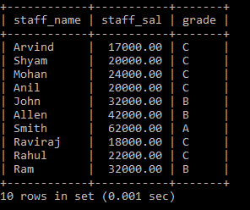

1. 6. Display the Staff Name, Hire date and day of the week on which staff was hired. Label the column as DAY. Order the result by the day of the week starting with Monday. Hint :Use to_char with hiredate and formats ‘DY’ and ’D’

Ans- select staff_name,hiredate,dayname(hiredate) as DAY from staff_masters order by ( case when dayofweek(hiredate)=1 then 8 else dayofweek(hiredate) end);

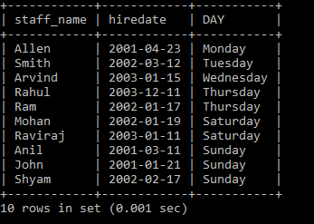

1. Write a query to find the position of third occurrence of ‘i’ in the given word ‘Mississippi’.

Ans- MariaDB [rdbms]> select length(substring_index("Mississippi","i",3))+1;

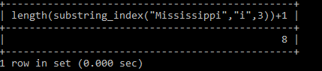

1. Write a query to find the pay date for the month. Pay date is the last Friday of the month. Display the date in the format “Twenty Eighth of January, 2002”. Label the heading as PAY DATE. Hint: use to_char, next_day and last_day functions

Ans-MariaDB [rdbms]> select date_format(last_day(now())-((7+weekday(last_day(now()))-4)%7),'%D of %M,%Y') as "PAY DATE";

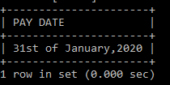

1. Display Student code, Name and Dept Name. Display “Electricals” if dept code = 20, “Electronics” if Dept code =30 and “Others” for all other Dept codes in the Dept Name column. Hint : Use Decode

Ans- MariaDB [rdbms]> select student_code,student_name,case dept_code when 20 then "Electricals" when 30 then "Electronics" else "Others" end as Dept_Name from student_masters;

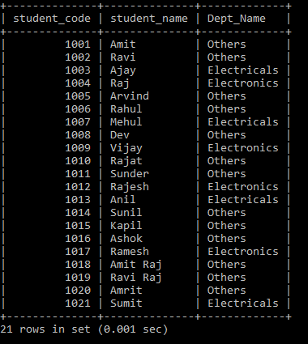

## 2.2: Group Functions:

1. Display the Highest, Lowest, Total & Average salary of all staff. Label the columns Maximum, Minimum, Total and Average respectively for each Department code. Also round the result to the nearest whole number.

Ans- MariaDB [rdbms]> select round(max(staff_sal)) as "MAX",round(min(staff_sal)) as "MIN",round(sum(staff_sal)) as "TOTAL",round(avg(staff_sal)) as "Average" from staff_masters group by dept_code;

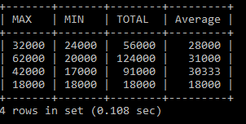

1. Display Department code and number of managers working in that department. Label the column as ‘Total Number of Managers’ for each department.

Ans- MariaDB [rdbms]> select Dept_code,count(Mgr_code) as "Total Number of Managers" from staff_masters group by dept_code;

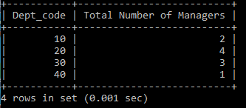

1. Get the Department number, and sum of Salary of all non-managers where the sum is greater than 20000.

Ans- MariaDB [rdbms]> select Dept_code as "Department Number",sum(staff_sal) as "Staff Salary" from staff_masters where (Staff_code not in (select mgr_code from staff_masters)) group by dept_code having sum(staff_sal)>20000;

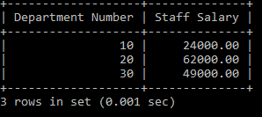

# JOINS AND SUBQUERIES

## 3.1: Joins and Subqueries

1. Write a query which displays Staff Name, Department Code, Department Name, and Salary for all staff who earns more than 20000.

Ans-MariaDB [rdbms]> select m.staff_name,m.dept_code,m.staff_sal,d.dept_name from staff_masters as m left join department_masters as d on m.dept_code=d.dept_code where staff_sal>20000;

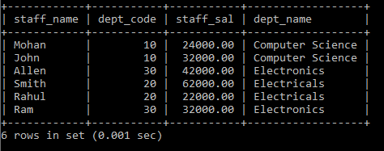

1. Display Staff Code, Staff Name, Department Name, and his manager’s number and name. Label the columns Staff#, Staff, Mgr#, Manager.

Ans-MariaDB [rdbms]> select m.staff_code as "Staff#",m.staff_name as Staff,d.dept_name,m.mgr_code as "Mgr#",m1.staff_name as "Manager" from staff_masters as m, department_masters as d,staff_masters as m1 where m.dept_code=d.dept_code and m.mgr_code=m1.staff_code;

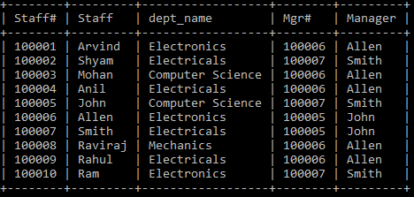

1. Create a query that will display Student Code, Student Name, Book Code, and Book Name for all students whose expected book return date is today.

Ans-MariaDB [rdbms]> select s.student_code,s.student_name,t.book_code,m.book_name from student_masters as s,book_masters as m,book_transactions as t where s.student_code=t.student_code and t.book_code=m.book_code and t.book_expected_return_date=now();



1. Create a query that will display Staff Code, Staff Name, Department Name, Designation name, Book Code, Book Name, and Issue Date for only those staff who have taken any book in last 30 days. . If required, make changes to the table to create such a scenario.

Ans- MariaDB [rdbms]> select s.staff_code,s.staff_name,d.dept_name,ds.design_name,bt.book_code,bm.book_name,bt.book_issue_date from staff_masters as s,department_masters as d,designation_masters as ds,book_transactions as bt,book_masters as bm where s.design_code=ds.design_code and s.dept_code=d.dept_code and s.staff_code=bt.staff_code and timestampdiff(day,bt.book_issue_date,now())<30 and bt.book_code=bm.book_code;

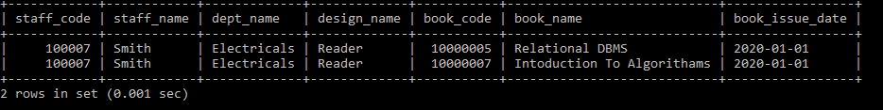

1. Generate a report which contains the following information.

Staff Code, Staff Name, Designation Name, Department, Book Code, Book Name,

Author, Fine For the staff who has not returned the book. Fine will be calculated as Rs. 5 per day.

Fine = 5 * (No. of days = Current Date – Expected return date). Include records in the table to suit this problem statement

Ans- MariaDB [rdbms]> select s.staff_code,s.staff_name,ds.design_name,d.dept_name,bt.book_code,bm.book_name,bm.book_pub_author,5*timestampdiff(day,bt.book_expected_return_date,bt.book_actual_return_date) as FINE from staff_masters s,designation_masters ds,department_masters d,book_transactions bt,book_masters bm where s.dept_code=d.dept_code and s.design_code=ds.design_code and bt.staff_code=s.staff_code and bt.book_code=bm.book_code and bt.book_actual_return_date>bt.book_expected_return_date;

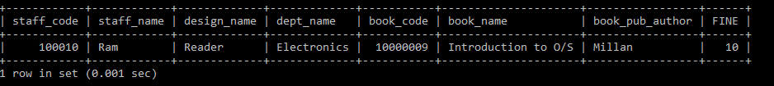

1. List Staff Code, Staff Name, and Salary for those who are getting less than the average salary of organization.

Ans- MariaDB [rdbms]> select staff_code,staff_name,staff_sal from staff_masters where staff_sal<(select avg(staff_sal) from staff_masters);

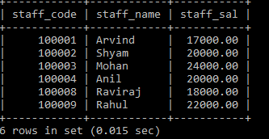

1. Display Author Name, Book Name for those authors who wrote more than one book.

Ans- MariaDB [rdbms]> select book_pub_author,book_name from book_masters group by book_pub_author having count(book_name)>1;

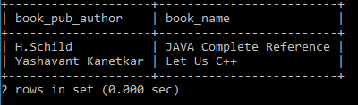

1. Display Staff Code, Staff Name, and Department Name for those who have taken more than one book.

Ans- MariaDB [rdbms]> select bt.staff_code,s.staff_name,d.dept_name from book_transactions bt,staff_masters s,department_masters d where bt.staff_code=s.staff_code and s.dept_code=d.dept_code group by bt.staff_code having count(bt.book_code)>1;

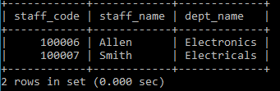

1. Display the Student Code, Student Name, and Department Name for that department in which there are maximum number of student studying.

Ans- MariaDB [rdbms]> select s.student_code,s.student_name,d.dept_name from student_masters s,department_masters d where s.dept_code=d.dept_code and s.dept_code=(select dept_code from student_masters group by dept_code order by count(dept_code) desc limit 1);

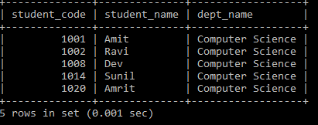

1. Display Staff Code, Staff Name, Department Name, and Designation name for those who have joined in last 3 months.

Ans-MariaDB [rdbms]> select s.staff_code,s.staff_name,d.dept_name,ds.design_name from staff_masters s, department_masters d,designation_masters ds where s.dept_code=d.dept_code and ds.design_code=s.design_code and timestampdiff(month,hiredate,now())<=3;



1. Display the Manager Name and the total strength of his/her team.

Ans-MariaDB [rdbms]> select s1.staff_name,s2.mgr_code,count(s2.staff_code) from staff_masters s1,staff_masters s2 where s2.mgr_code=s1.staff_code group by s2.mgr_code;

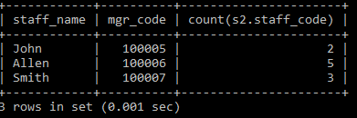

1. Display the details of books that have not been returned and expected return date was last Monday. Book name should be displayed in proper case.. Hint: You can change /add records so that the expected return date suits this problem statement

Ans- MariaDB [rdbms]> select* from book_transactions bt,book_masters bm where bm.book_code=bt.book_code and bt.book_actual_return_date is null and curdate()-((7+weekday(curdate()))%7)=bt.book_expected_return_date;



1. Write a query to display number of people in each Department. Output should display Department Code, Department Name and Number of People.

Ans- MariaDB [rdbms]> select s.dept_code,d.dept_name,count(*) as "Number Of People" from staff_masters s,department_masters d,student_masters s2 where s2.dept_code=s.dept_code and s.dept_code=d.dept_code group by s.dept_code;

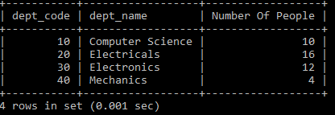

## 4.1: Database Objects

1. Create the Customer table with the following columns.

CustomerId int(5)

Cust_Name varchar(20)

Address1 Varchar(30)

Address2 Varchar(30)

Ans- MariaDB [rdbms]> create table customer (CustomerId int(5),Cust_Name varchar(20),Address1 varchar(30),Address2 varchar(30));

Query OK, 0 rows affected (0.166 sec)

1. Modify the Customer table Cust_Name column of datatype with Varchar2(30), rename the column to CustomerName and it should not accept Nulls.

Ans- MariaDB [rdbms]> alter table customer change cust_name CustomerName varchar(30) not null;

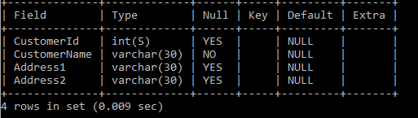

1. a) Add the following Columns to the Customer table.

Gender Varchar(1)

Age int(3)

PhoneNo int(10)

Ans- MariaDB [rdbms]> ALTER TABLE Customer add column gender varchar(1),add column age int(3),add PhoneNo int(10);



b) Rename the Customer table to Cust_Table

Ans- MariaDB [rdbms]> rename table customer to Cust_Table;

Query OK, 0 rows affected (0.081 sec)

1. Insert rows with the following data in to the Customer table.

Insert into customer values: (1000, ‘Allen’, ‘#115 Chicago’, ‘#115 Chicago’, ‘M’, ‘25, 7878776’)

In similar manner, add the below records to the Customer table:

1001, George, #116 France, #116 France, M, 25, 434524

1002, Becker, #114 New York, #114 New York, M, 45, 431525

MariaDB [rdbms]> insert into Cust_Table values(1000,'Allen','#115 Chicago','#115 Chicago','M',25,7878776);

MariaDB [rdbms]> insert into Cust_Table values(1001,'George','#116 France','#116 France','M',25,434524);

MariaDB [rdbms]> insert into Cust_Table values(1002,'Becker','#114 New York','#116 New York','M',25,431525);

1. Add the Primary key constraint for Customerld with the name Custld_Prim.

Ans- MariaDB [rdbms]> alter table cust_table add constraint CustId_Prim primary key(CustomerId);

1. Insert the row given below in the Customer table and see the message generated by the Oracle server.

1002, John, #114 Chicago, #114 Chicago, M, 45, 439525

Ans- MariaDB [rdbms]> insert into cust_table values(1002, 'John', '#114 Chicago', '#114 Chicago', 'M', 45, 439525);

1. Disable the constraint on CustomerId, and insert the following data:

1002, Becker, #114 New York, #114 New york , M, 45, 431525

1003, Nanapatekar, #115 India, #115 India , M, 45, 431525

Ans- MariaDB [rdbms]> alter table cust_table drop primary key;



MariaDB [rdbms]> insert into cust_table values(1002, 'Becker', '#114 New York', '#114New york' ,'M', 45, 431525);

MariaDB [rdbms]> insert into cust_table values(1003, 'Nanapatekar', '#115 India', '#115 India' , 'M', 45, 431525);

1. Enable the constraint on CustomerId of the Customer table, and see the message generated by the Oracle server.

Ans- MariaDB [rdbms]> alter table cust_table add constraint custid_prim primary key(customerid);

ERROR 1062 (23000): Duplicate entry '1002' for key 'PRIMARY'



1. Drop the constraint Custld_Prim on CustomerId and insert the following Data. Alter Customer table, drop constraint Custid_Prim.

1002, Becker, #114 New York, #114 New york , M, 45, 431525, 15000.50

1003, Nanapatekar, #115 India, #115 India , M, 45, 431525, 20000.50

Ans- MariaDB [rdbms]> insert into cust_table values(1002, 'Becker', '#114 New York', '#114 New york' , 'M', 45, 431525, 15000.50);

ERROR 1136 (21S01): Column count doesn't match value count at row 1

MariaDB [rdbms]> insert into cust_table values(1003, 'Nanapatekar', '#115 India', '#115 India' , 'M', 45, 431525, 20000.50);

ERROR 1136 (21S01): Column count doesn't match value count at row 1

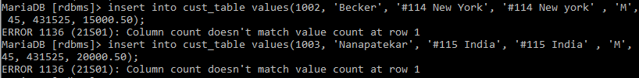

1. Delete all the existing rows from Customer table, and let the structure remain itself using TRUNCATE statement.

Ans- MariaDB [rdbms]> truncate cust_table;



1. In the Customer table, add a column E_mail.

Ans- MariaDB [rdbms]> alter table cust_table add column email varchar(20);



1. Drop the E_mail column from Customer table.

Ans- MariaDB [rdbms]> alter table cust_table drop email;



1. Create the Suppliers table based on the structure of the Customer table. Include only the CustomerId, CustomerName, Address1, Address2, and phoneno columns.

Name the columns in the new table as SuppID, SName, Addr1, Addr2, and Contactno respectively.

Ans-MariaDB [rdbms]> create table suppliers(suppid int(5),sname varchar(30),addr1 varchar(30),addr2 varchar(30),contactno int(10));



1. Drop the above table and recreate the following table with the name CustomerMaster.

CustomerId int(5) Primary key(Name of constraint is CustId_PK)

CustomerName Varchar(30) Not Null

Addressl Varchar(30) Not Null

Address2 Varchar(30)

Gender Varchar(l)

Age int(3)

PhoneNo int(10)

Ans-MariaDB [rdbms]> drop table cust_table;

Query OK, 0 rows affected (0.072 sec)

MariaDB [rdbms]> create table customermaster(CustomerId int(5), CustomerName Varchar(30) Not Null, Addressl Varchar(30) Not Null,Address2 Varchar(30),gender varchar(1),Age int(3),PhoneNo int(10));

Query OK, 0 rows affected (0.104 sec)

MariaDB [rdbms]> alter table customermaster add constraint custid_pk primary key(customerid);

Query OK, 0 rows affected, 1 warning (0.323 sec)

Records: 0 Duplicates: 0 Warnings: 1

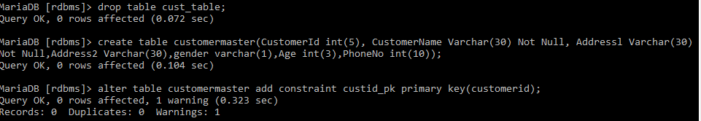

1. Create the AccountsMaster table with the following Columns. Use auto generate to generate Account number

Customerld int(5)

AccountNumber int(10,2) Primary key(Name of constraint is Acc_PK)

AccountType Char(3)

LedgerBalance int(10,2) Not Null

Ans-MariaDB [rdbms]> create table accountsmaster(CustomerId int(5), accountnumber double(10,2) primary key auto_increment,accounttype varchar(3),ledgerbalance double(10,2) not null);

Query OK, 0 rows affected (0.095 sec)

1. Relate AccountsMaster table and CustomerMaster table through Customerld column with the constraint name Cust_acc.

Ans-MariaDB [rdbms]> alter table accountsmaster add constraint cust_acc foreign key(customerid) references customermaster(customerid);

Query OK, 0 rows affected (0.430 sec)

Records: 0 Duplicates: 0 Warnings: 0

1. Insert the following rows to the CustomerMaster table:

1000, Allen, #115 Chicago, #115 Chicago, M, 25, 7878776

1001, George, #116 France, #116 France, M, 25, 434524

1002, Becker, #114 New York, #114 New York, M, 45, 431525

Ans-MariaDB [rdbms]> insert into customermaster values(1000, 'Allen', '#115 Chicago', '#115 Chicago', 'M', 25, 7878776);

Query OK, 1 row affected (0.026 sec)

MariaDB [rdbms]> insert into customermaster values(1001, 'George', '#116 France', '#116 France', 'M', 25, 434524);

MariaDB [rdbms]> insert into customermaster values(1002, 'Becker', '#114 New York', '#114 New York', 'M', 45, 431525);

1. Modify the AccountMaster table with the Check constraint to ensure AccountType should be either NRI or IND.

Ans-MariaDB [rdbms]> alter table accountsmaster add constraint check_account check(accounttype="NRI" or accounttype="IND");

1. Modify the AccountsMaster table keeping a Check constraint with the name Balance_Check for the Minimum Balance which should be greater than 5000.

Ans-MariaDB [rdbms]> alter table accountsmaster add constraint balance_check check(ledgerbalance>5000);

1. Modify the AccountsMaster table such that if Customer is deleted from Customer table then all his details should be deleted from AccountsMaster table.

Ans- MariaDB [rdbms]> alter table accountsmaster add constraint cust_accounts foreign key(customerid) references customermaster(customerid) on delete cascade;



1. Create Backup copy for the AccountsMaster table with the name ‘AccountDetails’.

Ans- MariaDB [rdbms]> create table AccountDetails as select * from accountsmaster;

1. Create a view ‘Acc_view’ with columns Customerld, CustomerName, AccountNumber, AccountType, and LedgerBalance from AccountsMaster. In the view Acc_view, the column names should be CustomerCode, AccountHolderName, AccountNumber, Type, and Balance for the respective columns from AccountsMaster table.

Ans-MariaDB [rdbms]> create view Acc_view as (select c.customerid as 'customercode',c.customername as 'accountholdername',a.accountnumber,a.accounttype as 'type',a.ledgerbalance as 'balance' from accountsmaster a,customermaster c where a.customerid=c.customerid);

1. Create a view on AccountsMaster table with name vAccs_Dtls. This view should list all customers whose AccountType is ‘IND’ and their balance amount should not be less than 10000. Using this view any DML operation should not violate the view conditions.

Ans- MariaDB [rdbms]> create or replace definer=current_user sql security definer view vAccs_Dtls as select * from accountsmaster where accounttype="IND" and ledgerbalance<10000;



1. Create a view accsvw10 which will not allow DML statement against it.

Ans- MariaDB [rdbms]> create or replace definer=current_user sql security definer view accsvvw10 as select * from accountsmaster ;



1. Insert three sample rows by using the above auto generate in Department_Masters table.

Ans-

MariaDB [rdbms]> alter table department_masters change dept_code dept_code int(2) auto_increment;

MariaDB [rdbms]> insert into department_masters(dept_name) values('IT');

MariaDB [rdbms]> insert into department_masters(dept_name) values('EEE');

MariaDB [rdbms]> insert into department_masters(dept_name) values('ECE');

MariaDB [rdbms]> select * from department_masters;

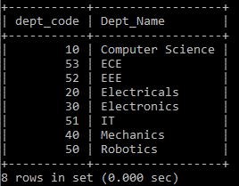

1. Get information on the index No_Name from the Data Dictionary.
2. Create synonym synEmp for the EMP table.
3. Get Information on synonym synEmp from the Data Dictionary.
4. Note: Perform this after creating the Employee Table mentioned in the next Lab assignment. Create Index on HireDate column and give the name as idx_emp_hiredate for this object.Data Manipulation Language

Ans- MariaDB [rdbms]> create index idx_emp_hiredate on emp(hiredate);

## 5.1: Data Manipulation Language

1. Create Employee table with same structure as EMP table.

SQL>Create table employee as select * from emp where 1=3

SQL>desc employee

|  |  |  |
| --- | --- | --- |
| **Name** | **Null?** | **Type** |
| EMPNO | NOT NULL | int(4) |
| ENAME |  | VARCHAR(10) |
| JOB |  | VARCHAR(50) |
| MGR |  | int(4) |
| HIREDATE |  | DATE |
| SAL |  | int(7,2) |
| COMM |  | int(7,2) |
| DEPTNO |  | int(2) |

SQL>select * from employee

Ans- MariaDB [rdbms]> create table employee as select * from emp where 1=3;

MariaDB [rdbms]> desc employee;

MariaDB [rdbms]> select * from employee;

Empty set (0.001 sec)

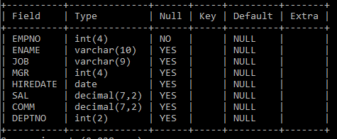

1. Write a query to populate Employee table using EMP table’s empno, ename, sal, deptno columns.

SQL>select * from employee

|  |  |  |  |  |  |  |  |
| --- | --- | --- | --- | --- | --- | --- | --- |
| **EMPNO** | **ENAME** | **JOB** | **MGR** | **HIREDATE** | **SAL** | **COMM** | **DEPTNO** |
| 7369 | SMITH |  |  |  | 800 |  | 20 |
| 7499 | ALLEN |  |  |  | 1600 |  | 30 |
| 7521 | WARD |  |  |  | 1250 |  | 30 |
| 7566 | JONES |  |  |  | 2975 |  | 20 |
| 7654 | MARTIN |  |  |  | 1250 |  | 30 |
| 7698 | BLAKE |  |  |  | 2850 |  | 30 |
| 7782 | CLARK |  |  |  | 2450 |  | 10 |
| 7788 | SCOTT |  |  |  | 3000 |  | 20 |
| 7839 | KING |  |  |  | 5000 |  | 10 |
| 7844 | TURNER |  |  |  | 1500 |  | 30 |
| 7876 | ADAMS |  |  |  | 1100 |  | 20 |
| 7900 | JAMES |  |  |  | 950 |  | 30 |
| 7902 | FORD |  |  |  | 3000 |  | 20 |
| 7934 | MILLER |  |  |  | 1300 |  | 10 |

14 rows selected.

Ans- MariaDB [rdbms]> insert into employee(empno,ename,sal,deptno) select empno,ename,sal,deptno from emp;

MariaDB [rdbms]> select * from employee;

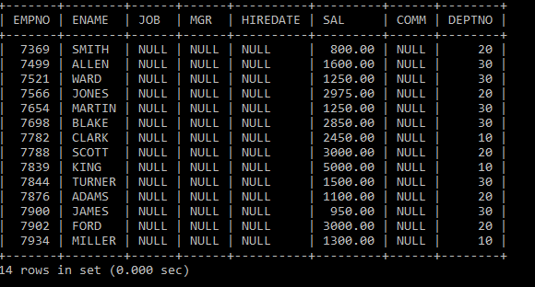

1. Write a query to change the job and deptno of employee whose empno is 7698 to the job and deptno of employee having empno 7788.

MariaDB [rdbms]> update employee set deptno=(select deptno from employee where empno=7788),job = (select job from employee where empno =7788) where empno=7698;

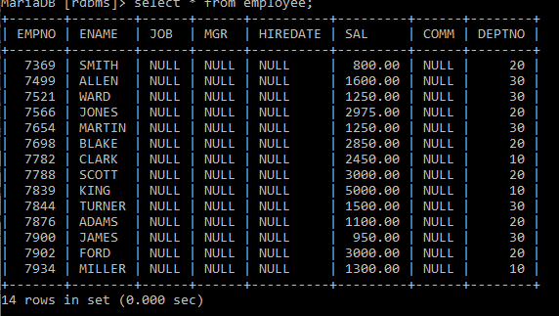

1. Delete the details of department whose department name is ‘SALES’.
2. Write a query to change the deptno of employee with empno 7788 to that of employee having empno 7698.

Ans- update employee set deptno = (select deptno from employee where empno =7698) where empno=7778;



1. Insert the following rows to the Employee table through parameter substitution.

* 1000,Allen, Clerk,1001,12-jan-01, 3000, 2,10
* 1001,George, analyst, null, 08 Sep 92, 5000,0, 10
* 1002, Becker, Manager, 1000, 4 Nov 92, 2800,4, 20
* 1003, 'Bill', Clerk, 1002, 4 Nov 92,3000, 0, 20

Ans-MariaDB [rdbms]> insert into employee values (1000,'Allen', 'Clerk',1001,'2001-01-12', 3000, 2,10),(1001,'George', 'analyst', null,'1992-09-08', 5000,0, 10),(1002, 'Becker', 'Manager', 1000, '1992-11-4', 2800,4, 20),(1003, 'Bill', 'Clerk', 1002,'1992-11-04',3000, 0, 20);

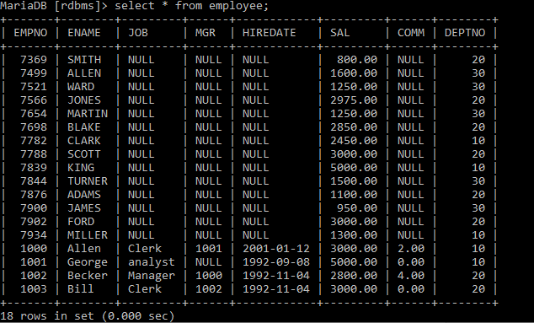

## 6.1: Transaction Control Language Statements

1. Insert rows with the following data into the Customer table. 6000, John, #115 Chicago, #115 Chicago, M, 25, 7878776, 10000

* 6001, Jack, #116 France, #116 France, M, 25, 434524, 20000
* 6002, James, #114 New York, #114 New York, M, 45, 431525, 15000.50

Use parameter substitution.

Ans-MariaDB [rdbms]> insert into customermaster values(6000, 'John', '#115 Chicago', '#115 Chicago', 'M', 25, 7878776, 10000),(6001, 'Jack', '#116 France', '#116 France', 'M', 25, 434524, 20000),(6002, 'James', '#114 New York', '#114 New York', 'M', 45, 431525, 15000.50);



1. Create a Savepoint named ‘SP1’ after third record in the Customer table .

Ans- MariaDB [rdbms]> start transaction;

MariaDB [rdbms]> savepoint sp1;

1. Insert the below row in the Customer table.

6003, John, #114 Chicago, #114 Chicago, M, 45, 439525, 19000.60

MariaDB [rdbms]> insert into customermaster values(6003, 'John', '#114 Chicago', '#114 Chicago', 'M', 45, 439525, 19000.60);

1. Execute rollback statement in such a way that whatever manipulations done before Savepoint sp1 are permanently implemented, and the ones after Savepoint SP1 are not stored as a part of the Customer table.

Ans- MariaDB [rdbms]> rollback to sp1;

